**Automated Pothole-Detection Methods**

1. **INTRODUCTION**

A pothole is a hole in a road surface that results from gradual damage caused by a traffic and weather conditions. The general process of pothole detection consists of four steps: data acquisition, data pre-processing, feature extraction, and pothole classification. The pothole classification step determines the existence of potholes by applying a pothole-detection algorithm based on the features.

1. Application - To contribute to the prevention of traffic accidents and the smooth flow of traffic. Identifying and managing potholes in advance plays an important role in securing driver safety and preventing traffic accidents.
2. Focus and purpose**: This paper focuses** the automated pothole-detection methods can be classified into three types according to the technology used in the pothole-recognition process: a vision-based method, a vibration-based method, and a 3D reconstruction-based method. In this paper, three methods are compared, and the strengths and weaknesses of each method are summarized.
3. Linking words: pothole; automated detection; vision; vibration; 3D reconstruction; image processing; deep learning
4. Broad Problem: Designing a pothole detector using machine learning/image processing.
5. Linking words: pothole; automated detection;; image processing; deep learning, machine learning
6. The Literature review /previous work:

* Baek proposed a pothole-detection and -classification method based on

edge detection using pavement images as input data. The proposed method consists of

three phases: image pre processing, feature extraction of road damage, and road-damage

classification. In the process of image pre processing, RGB image data were converted

to gray-scale image data, and the objects in images except potholes were detected via

object-detection algorithm. The contour of the pothole in the pre processed images was extracted via edge-detection algorithm for feature extraction. Potholes were detected and

classified via YOLO algorithm in the road-damage-classification phase. Itwas evaluated by distortion rate and restoration rate of the image, and the accuracy of the classification. The dataset used in the performance evaluation process is the Global Road Damage Detection Challenge 2020 dataset [11]. The experimental results showed that the mean-squared error (MSE) of the distortion rate and restoration rate of the proposed method had errors of 0.2–0.44. The average of the classification

accuracy and precision of the proposed method were 0.7786 and 0.8345. The accuracy and

precision of pothole detection presented as experimental results of this study are restricted

to one pothole in the image data. It is confirmed that the accuracy of pothole detection was relatively low when there were multiple potholes in one image=

datum. In addition, it is possible to detect the shape of a pothole by applying

* Park presented a method for automated pothole detection that applied

different YOLO models using images as input data. Three YOLO models such as YOLOv4,

YOLOv4-tiny, and YOLOv5 were applied in the process of training and testing. The dataset

of which is found was composed of 665 pothole images and was divided

into training, validation, and testing subsets. First of all, the images in the training subset

were converted to be suitable for the various YOLO models. The models were trained

and validated until the loss function reached a steady-state line. Next, the performance of

three YOLO models was evaluated using mean average precision at 50% intersection-over

union threshold (mAP@0.5). The low accuracy when detecting small potholes located at a long distance is a limitation of this study. In addition, it is judged as a limitation that the study was not carried out in bad weather conditions and under insufficient light conditions.

* Deepak Kumar Dewangan proposed a pothole-detection method based on

CNN with an embedded vehicle prototype.

The system consisted of three modules: a pothole-detection module, a data-processing module, and an embedded autonomous-vehicle-system (AVS) module. The dataset that was used in the process of training in a pothole-detection module was composed of 3915 images.

The experimental results showed that the accuracy, precision, recall, and F1 score of the proposed method were 0.9902, 0.9903, 0.9903, and 0.9833, respectively. The authors explained that the proposed method had better performance than the existing methods [16,22–25] through the experimental results.

It is judged that a real-time pothole-detection system

using low-cost edge devices such as Jetson Nano can be implemented based on the research results of this paper.

g) Linking words: YOLO, pre-processed, AVS module, Detecting, Image processing, Previous work, efficiency of works.

h) Current state of the problem: A full-sized example of the footage that was taken from within the vehicle using the camera mounted to the windscreen of the vehicle can clearly be seen that there is a lot of information within the image (such as foliage) that is not relevant to pothole detection. This full-sized image is then fed into the algorithm which first extracts the road before any potholes are detected. the algorithm also determined that in the event that two potholes are closely spaced together, they would be grouped together and seen as a single contour. This was mostly the case with potholes that were further away from the vehicle.

i) Linking words: Example, Vehicle, Extracts pothole, pothole determined, driver alerted.

j) Motivation:  The motivation behind the proposed framework lies in the deficiencies of current practice and the potential of gradually and inexpensively converting passenger vehicles into ubiquitous sensors and reporters of the roads’ condition. The work presented in this paper is the first step to achieve our objective. We use a window mounted camera on an equipped passenger vehicle that collects visual pavement data. This data is then used to validate our method for automated pothole detection in pavement images.

k) Linking words: Motivation, Proposed Framework, Mounted camera, Image captured, Automatically Processed, detection.

i) Novelty:  The main novelty resides on the application of latest progress in Artificial Intelligence to learn the visual appearance of potholes. We built a large dataset of images with pothole annotations. They contained road scenes from different cities in the world, taken with different cameras, vehicles and viewpoints under varied environmental conditions

m) Linking words: Novelty, AI, visual appearance, pothole, data, cameras, environmental, conditions.

n) Advantages of the System:

1. Pothole present on the road can be effectively identified.
2. Road maintenance authority gets information and prior knowledge regarding the places where they required for repairs to the road.
3. Cost of identification of pothole is reduced compared with other systems for detections of pothole.

o) Disadvantages of the System:

1. If the vehicle is at very high speed, accuracy of pothole detection may be less.

2. In the rainy season and night, the identification of the pothole on the roads becomes a difficult task.

P) Contents:

|  |  |  |
| --- | --- | --- |
| **S. NO.** | **TITLE** | **PAGE NO.** |
| 1. | Problem formulation | 6 |
| 2. | Methodology   1. Model 2. Working | 6 |
| 3. | Accuracy | 9 |
| 4. | Conclusion | 10 |

1. **PROBLEM FORMULATION**

The general process of pothole detection consists of four steps: data acquisition, data pre processing, feature extraction, and pothole classification. After processing the data, we’ll go for feature extraction.

The feature-extraction step is a process of finding a factor to distinguish between potholes and non-potholes in the preprocessed data. In the feature-extraction step, it is important to consider the type and characteristics of the preprocessed data when looking for factors for pothole classification. The potholeclassification step determines the existence of potholes by applying a pothole-detection algorithm based on the features. Hence, The damaged road consisting of pothole would get a outlined green mark on it.

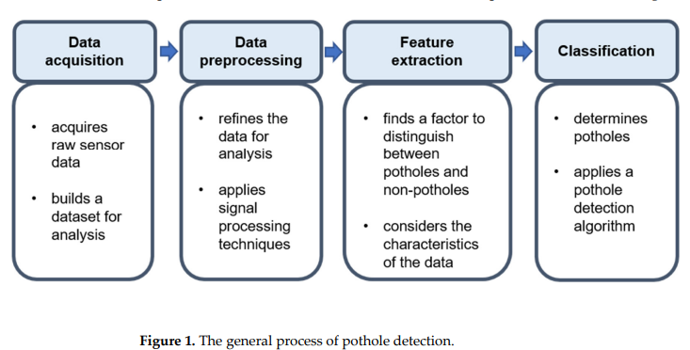

1. **METHODOLOGY (part 1)**
2. A Vision-Based Method (A MATLAB prototype):

The proposed method consists of two processes: pothole detection and pothole segmentation. In the process of pothole detection, the wavelet energy field of the asphalt image was constructed by morphological processing and geometric criteria. The detected pothole was segmented via Markov random field model and the pothole edge was extracted accurately. The contours within the frame that describe the specific road colour sections are then determined.

* THE POTHOLE MODEL

The pothole model is derived from the assumption that any strong dark edge within the extracted road surface is deemed a pothole edge if it adheres to certain size constraints. By inspecting Figure 1, it can be seen that one of the characteristics describing the potholes is a large dark shadow area. At this point, potholes that do not have dark edges and only have different color variations within them like sand or dirt are disregarded and will be studied in future work. The size constraints were obtained using the selection of images

withheld for parameter tuning. Any shape of contour that meets these conditions is deemed a pothole by the algorithm.

* WORKING OF ALGORITHM (part 1)
* 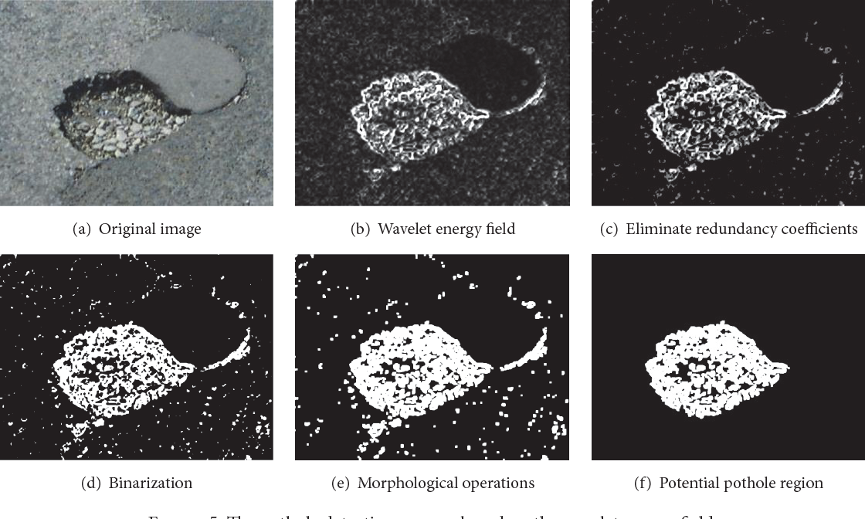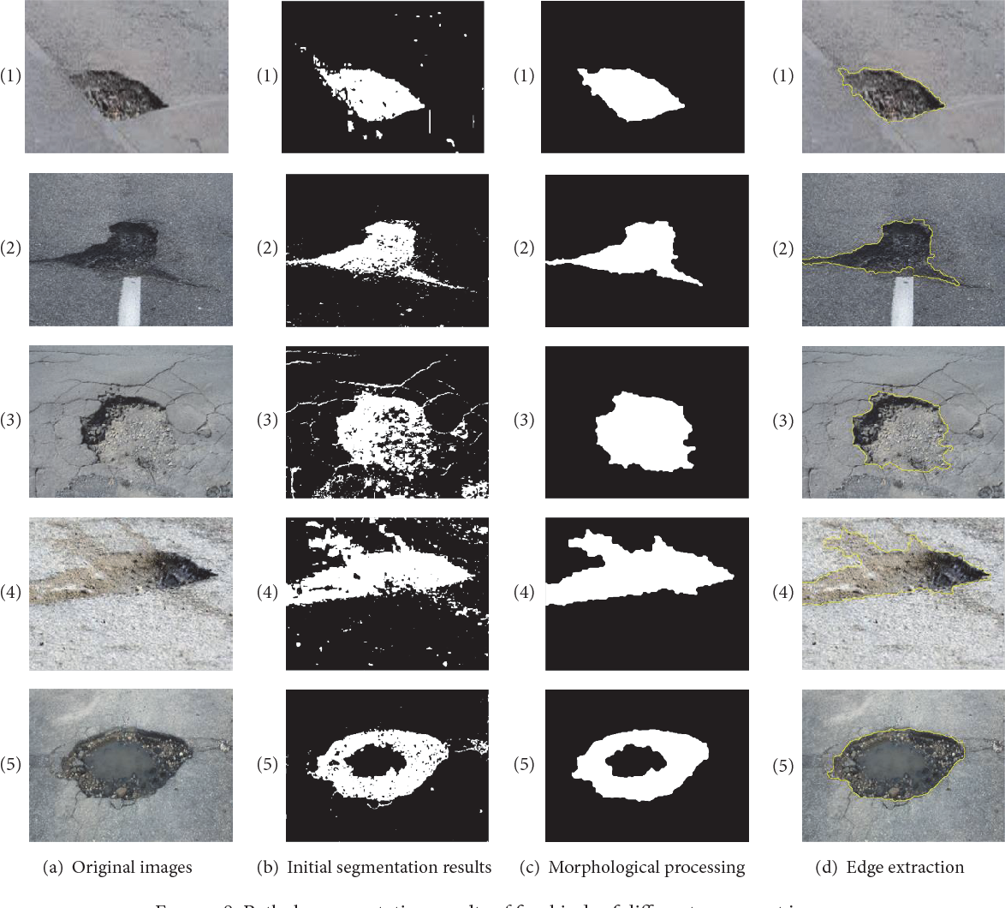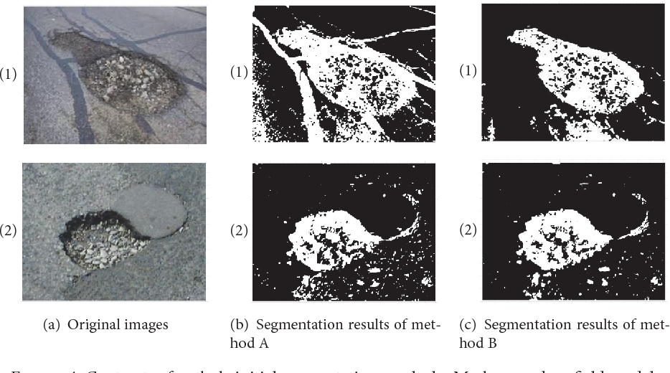

The proposed method consisted of proposed method consists of two processes: pothole detection and pothole segmentation. In the process of pothole detection, the wavelet energy field of the asphalt image was constructed by morphological processing and geometric criteria. The detected pothole was segmented via Markov random field model and the pothole edge was extracted accurately. The contours within the frame that describe the specific road colour sections are then determined.

The last contour detection is then applied to the dilated image to find the potholes within the road section. The contours are filtered and those that do not meet the size constraints of the pothole model are discarded. This last step filters out any small defects in the road that are not classified as potholes as well as the larger contours found on the outer boundary of the extracted road.

Authors proposed applying a more effective mathematic model as a future work to improve the accuracy of pothole detection.

1. **ACCURACY (part 1)**

The experimental results showed that the overall accuracy, precision, and recall of the proposed method were 0.867, 0.833, and 0.875, respectively.

* **METHODOLOGY (part 2)**

Vibration-Based Method (Type B):

The proposed method consists of three phases: data acquisition and preprocessing, abnormal-road-surface recognition, and abnormal-surface classification. The vehicle speed, acceleration, and position information were collected by the smartphone’s built-in accelerometer and Global Positioning Navigation system. The raw data were preprocessed using a Butterworth filter. The improved Gaussian model was used to recognize the abnormal road surface using the z-axis acceleration threshold condition. The training samples and the test samples were collected on two different roads for maintaining independence. The k-nearest neighbor (kNN) algorithm was used to classify the abnormal pavement types, including potholes and bumps.

The contours within the frame that describe the specific road colour sections are then determined.

* WORKING OF ALGORITHM (part 2)

It consisted of

* Experimental vehicle: A-class vehicle

(Cavalier) and SUV (Qoros 5)

* The smartphone is fixed on the handrail of the driver’s seat
* An Android-based app working on a

smartphone (Redmi Note 8 Pro)

* + Sampling frequency: 400 (Hz)

The raw data were pre processed using a Butterworth filter. The improved Gaussian model was used to recognize the abnormal road surface using the z-axis acceleration threshold condition.

The k-nearest neighbor (kNN) algorithm was used to classify the abnormal pavement types, including potholes and bumps

1. **ACCURACY (part 2)**

The accuracy was measured by comparing the field-measurement results for abnormal road surfaces such as potholes and bumps with the identification results of the proposed method. The test result shows that the accuracy of the recognition of the road-surface pothole is 96.03%, and the accuracy of the road-surface bump is 94.12%.

1. **CONCLUSION**

Feature extraction and training and testing play an important role in vision-based methods. Image-processing technologies such as edge detection and SIFT are applied in the process of feature extraction in those methods. Deep-learning technologies such as CNN, YOLO, and SVM are used in the process of training and testing in those methods. Vibration-based methods generally consist of three steps, namely data preprocessing, feature extraction, and classification. Signal-processing techniques such as filtering, Fourier transform, and correlation are applied in the process of data preprocessing and feature extraction. Machine-learning techniques such as k-nearest neighbor, linear regression, and random forest are used in the process of classification.

The algorithm is successful in the detection of potholes and an attempt will be made to upgrade it to include potholes with no visible edges (due to sand or dirt) in future research.

|  |  |  |  |
| --- | --- | --- | --- |
|  | **1.Pothole detection: the wavelet energy field is constructed by morphological processing, geometric criterions** | Accuracy: 86.7% Recall: 87.5% Precision: 83.3% | Machinelearning techniques such as k-nearest neighbor, linear regression, and random forest are used in the process of classification. |
| **Pothole segmentation: Markov random field model** |  |  |
| **2.Data preprocessing: Butterworth filter, Road-surface recognition: improved Gaussian model** | Accuracy rate **- Pothole: 96.03%** | Data preprocessing: Butterworth filter • Road-surface recognition: improved Gaussian model • Road-surface classification: k-nearest neighbour |
| Road-surface classification: KNN | - Bump: 94.12% |  |

APPENDIX 1

Citation 1 - There are various research efforts to automate the pothole detection process in roads using different approaches: sensor-based techniques [8][9][10][11][12], 3D reconstruction techniques (laser-based [13][14][15] and stereo vision-based [16][17][18][19][20]), image processing techniques [21][22][23][24][25][26][27][28], and model-based (machine-learning techniques and deep learning techniques) [29][30][31][32][33][34][35][36][37]. Senor-based techniques use vibration sensors to detect potholes.

APPENDIX 2

Citation 2 - The image processing object detectors are dependent on hand-crafted representations to extract low-level features. There were several previous image-processing research efforts to detect potholes in a single image/frame [21][22][23][24], and other video-based methods were proposed to detect potholes and count their number over a series of frames [21,[25][26][27][28]. The authors in [24] collected different frames and converted the frames into blurring grayscale images and then applied morphological and edge detection methods [55] to identify contours that are run through a Hough transform algorithm to extract features.

* ACKNOWLEDGEMENT

The authors would like to thank MTN for their continued financial support through the MTN Mobile Intelligence Lab.

* REFERENCE

CSIR, 2010. Potholes: Technical guide to their causes, identification and repair.

Available at: http://www.csir.co.za/pothole_guides/docs/Pothole_CSIR_tech_guide.pdf

Danti, A., Kulkarni, J. & Hiremath, P., 2012. An Image Processing Approach to Detect Lanes, Pot Holes and Recognize Road Signs in Indian Roads. International Journal of Modeling and Optimization, 2(6), pp. 658-662